Suppl 4. Funnel plots assessing publication bias for odds ratio of immune checkpoint inhibitor-induced hematological adverse events.
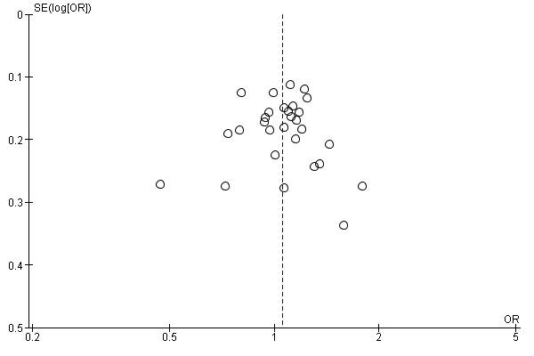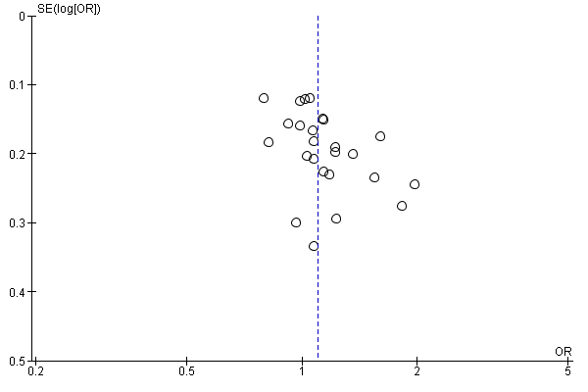
(A) Anemia (Grade I–V) (B) Neutropenia (Grade I–V)

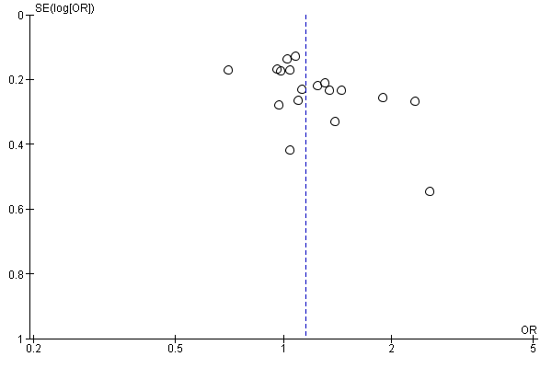
(C) Thrombocytopenia (Grade I–V)

