Supplementary information
Supplement to: Treatment outcomes and survival patterns of Asian patients with relapsed/refractory mantle cell lymphoma
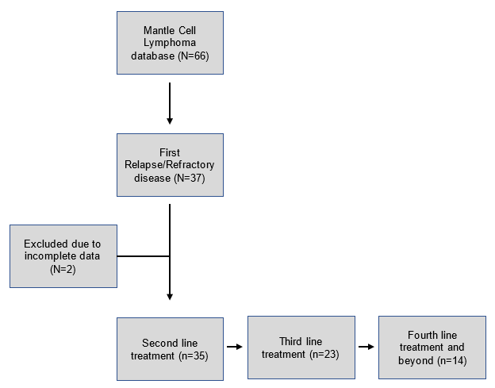
Supplementary Figure 1. Patient inclusion and treatment overview.

